OFFICIAL COORDINATION REQUEST FOR
NON-ROUTINE OPERATIONS AND MAINTENANCE

COORDINATION TITLE- 22BON096 MOC BON Modified Involuntary Spill Patterns
COORDINATION DATE- 05 Dec 2022
PROJECT- Bonneville Lock & Dam
RESPONSE DATE – preferably at FPOM on 8 December, NLT 15 December.

Description of the problem – Bonneville Lock & Dam, in coordination with Portland District, will be modifying the winter spill pattern for involuntary spill to minimize further erosion to the Bradford Island B-Branch riprap apron and to protect the B-Branch Fish Ladder. The erosion was discovered on September 15, 2022, after a routine forebay trash flushing operation (Photo 1). The erosion was inspected by an ROV, hydrosurvey, and land survey (as coordinated in 22BON089 MOC & MFR 22BON094). The B-Branch ladder will continue to operate with the FPP 1.5’ head differential criteria while feasible until repairs are made to the damaged apron. Portland District is working on contracting the repair to occur this winter and a separate MOC will be distributed soon.

Patterns have been developed for involuntary spill flows ranging from 1.2 kcfs to 300.2 kcfs. The modified spill pattern will be included as separate attachment. This modified involuntary spill pattern was developed and implemented in 2016/2017 for the previous B-Branch erosion occurrence. If involuntary spill is required, the modified spill pattern will prioritize gate openings to the northern and middle bays with spill distributed across bays 1-14 depending on river flow. Figures 1 & 2 are flow rates (kcfs) of involuntary spill during the dates of impact (November 20 – April 09) for the last 10 years at Bonneville Lock & Dam.

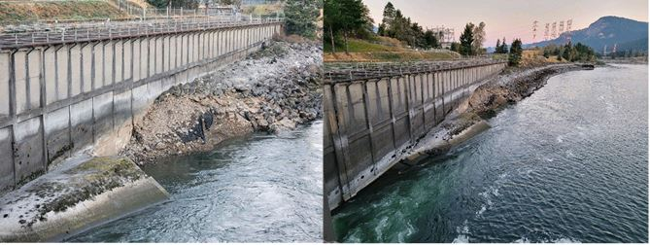
Photo 1: Left frame, close photo of damage to the B-Branch Fish Ladder apron. Right frame, overall photo of the damage. Photo obtained from MOC 22BON089.

Type of outage required

Impact on facility operation (FPP deviations) - The modified spill pattern deviates from the FPP Spill Management Section 2.2.1 Table BON-16 Spill Patterns and Section 2.2.4.4. regarding adjacent ladder attraction flow.

Impact on unit priority - The revision to involuntary spill patterns does not impact unit priority.

Impact on forebay/tailwater operation None

Impact on spill – The modified involuntary spill pattern will minimize further erosion near the Bradford Island B-Branch riprap and protect the ladder by distributing involuntary flows toward the northern and middle bays (Gates 1-14) depending on river flow.

Impact on facility operation Requires manually inputting the spill gate operations until GDACS is updated.

Dates of impacts/repairs Now until April 9, 2023

Length of time for repairs Now until April 9, 2023

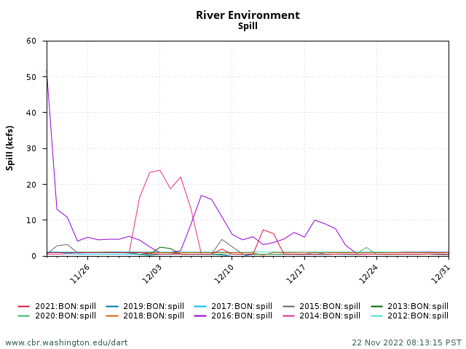
Figure 1: Involuntary spill (kcfs) during November 20 – December 31 for the past 10 years (2012-2021) at Bonneville Lock & Dam.

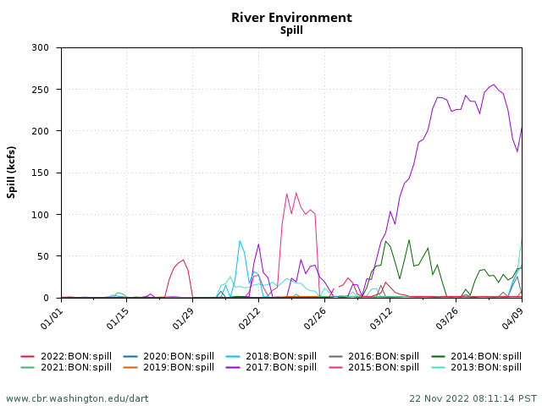
Figure 2: Involuntary spill (kcfs) during January 01 – April 09 for the past 10 years (2013-2022) at Bonneville Lock & Dam.

Analysis of potential impacts to fish

- 10-year average passage by run during the period of impact for adults and juvenile listed species, as appropriate for the proposed action and time of year;
Figure 3 is the 10-year average daily passage of adult salmonids at Bonneville Dam during the dates of impact between 11/20 – 04/09 that are potentially exposed to the impacts of the modified involuntary spill pattern.

Figure 3: Adult 10-Year Average Daily Passage for Period of Impact (11/20-04/09) at Bonneville Dam. Data obtained on 22 Nov 2022 11:01:20 PST. Columbia River DART (Data Access in Real Time) www.cbr.washington.edu/dart.
- Statement about the current year’s run (e.g., higher or lower than 10-year average);
- 2022 fall Chinook run is slightly lower than 10-year average fall Chinook run
- 2022 spring Chinook run is higher than 10-year average spring Chinook run
- 2022 total steelhead run is lower than the 10-year average total steelhead run
- 2022 coho run is higher than the 10-year average coho run
Data obtained for current year and 10-year average run comparison from Columbia River DART (2022) daily adult query for Bonneville Dam.
- Estimated exposure to impact by species and age class (i.e., number or percentage of run exposed to an impact by the action);
- Percent run of adult Chinook exposed to impact: 0.2%
- Percent run of adult steelhead exposed to impact: 1.6%
- Percent run of adult coho exposed to impact: 0.9%
Estimated exposure to impact by species was found by dividing 10-year average cumulative passage for dates of impact, divided by 10-year average total passage, multiplied by 100. Data was obtained from Columbia River DART (2022) using adult daily query for Bonneville Dam.
- Type of impact by species and age class (increased delay, exposure to predation, exposure to a route of higher injury/mortality rate, exposure to higher TDG, etc.);
Adult upstream migrants may experience an increased delay locating the B-Branch fish ladder entrance. This is because the modified involuntary spill pattern violates FPP section 2.2.4.4. which requires the adjacent bay (Gate 18) to be open to 1 stop (0.5’) to provide attraction flow to adjacent fish ladder. This delay in locating the fish ladder entrances will increase exposure to predators such as sea lions. If involuntary spill occurs with the modified spill pattern, the flow coming through the northern most bays of the dam may artificially attract adult migrants to the non-operating fish ladder, since Cascades Island fish ladder will be out of service for planned winter maintenance tentatively until the end of January. The modified spill pattern may further delay adult migrants in locating the B-Branch or other fish ladder entrances.

Juvenile downstream passage during the dates of impact (now-April 09) is low, as most juvenile peak passage occurs in spring and summer. If involuntary spill does occur, the modified spill pattern may cause a stall out area of flow, downstream of the non-operating bays. This stall out in flow may create increased delays in juvenile egress out of the spillway tailrace and increase their exposure to predators such as piscivorous birds and fish. We expect the piscivorous bird impact to be minimal due to low abundance of birds at Bonneville and low downstream passage during this time frame. Predation impacts from piscivorous fish are expected to be higher with the modified spill pattern compared to the FPP pattern.

Summary statement - expected impacts on:

Upstream migrants (including Bull Trout): Expected impacts to upstream migrants are increased delays in locating the B-Branch fish ladder entrances due to the loss of adjacent attraction flow from Gate 18, which may cause an increased risk to predation. We expect this impact to be minimal because the B-Branch entrance will maintain FPP 1.5’ head differential until feasible. All other operating fish ladder entrances will maintain the FPP 1.5’ entrance head differential. Additionally, sea lion abundance is typically low during this time of year and therein, potential predation is minimal. Once the Washington Shore and Cascades Island fish ladders are taken out of service, we expect that upstream migrants will be more attracted to the Powerhouse 1 (PH1) fish ladder entrances due to the outflow provided by the priority units.

Downstream migrants: Expected impacts to downstream migrants are minimal. The modified involuntary spill pattern may increase the risk to predation due to possible flow stall outs occurring with non-operating gates. However, we expect this potential impact to be minimal since downstream passage numbers are low during this time.

Lamprey: Impacts to adult lamprey are expected to be minimal. Using the 10-year average, 95% of the run for adult lamprey passage occurs during the end of August, with the last 10-year average passage day on November 17 (Columbia River DART, 2022). Adult lamprey that are in the spillway tailrace searching for the B-Branch entrance may experience a slight delay due to the change in spill pattern impacting adjacent fish ladder attraction flow. However, until the B-Branch apron is repaired, all operating fish ladder entrances (PH1 and B-Branch entrances) will maintain appropriate FPP 1.5’ head differential.

Expected impacts to juvenile lamprey are minimal. Involuntary spill will provide additional downstream routes for juvenile lamprey. Juvenile lamprey that use the spillway for downstream passage may experience an increased delay in egress and increased risk of predation due to the flow stall out that may occur downstream of non-operated bays.

Comments from agencies

Final coordination results

Please email or call with questions or concerns.
Thank you,

Becca Cates
Fisheries Biologist
Fish Passage Section
U.S. Army Corps of Engineers
Rebecca.i.cates@usace.army.mil

Tammy Mackey
NWP Operations Division Fishery Section
503-961-5733
Tammy.m.mackey@usace.army.mil

CITATIONS

Bonneville adult passage data obtained from:
DART Data Citation
Columbia River DART, Columbia Basin Research, University of Washington. (2022). Adult Passage Daily Counts. Available from https://www.cbr.washington.edu/dart/query/adult_daily

Bonneville spill data obtained from:
DART Data Citation
Columbia River DART, Columbia Basin Research, University of Washington. (2022). River Environment Graphics & Text. Available from https://www.cbr.washington.edu/dart/query/river_graph_text

Bonneville FPP criteria obtained from:
U.S. Army Corps of Engineers. (2022). Final 2022 fish passage plan (FPP) Chapter 2 – Bonneville Dam. Fish Passage Operations and Maintenance (FPOM). Retrieved November 21, 2022, from https://pweb.crohms.org/tmt/documents/fpp/2022/

